AI ASSISTANT CODING
ASSIGNMENT 3.1
2303A51994
B.Ranjith
TASK 1: Zero-Shot Prompting (Palindrome Number Program)
PROMPT: Write a Python function that checks whether a given number is a palindrome and returns True or False.
CODE: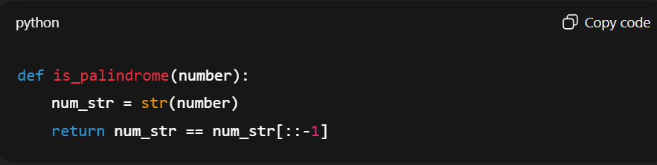
OUTPUTS:
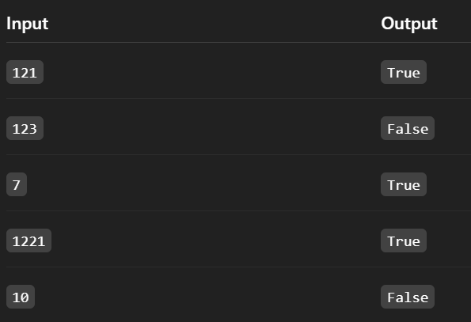

Explanation:
- The program checks if a number is the same when reversed.
- It works for positive integers but does not handle negative or invalid inputs.

TASK2: One-Shot Prompting (Factorial Calculation)
PROMPT: Write a Python function to calculate the factorial of a number.
Example: Input: 5 → Output: 120
CODE:
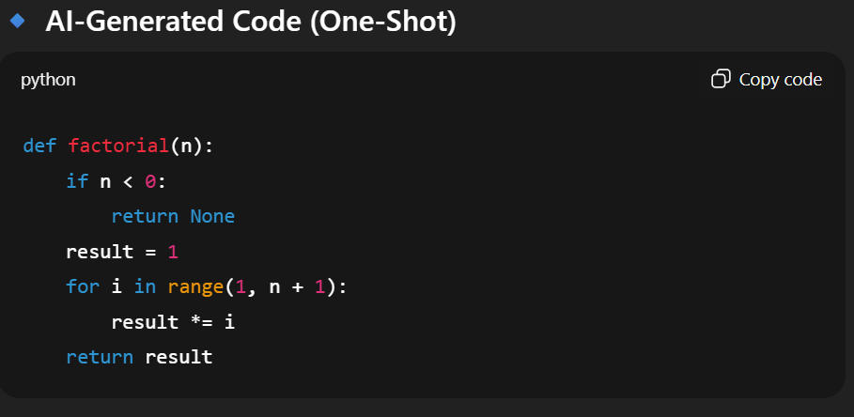

OUTPUTS:
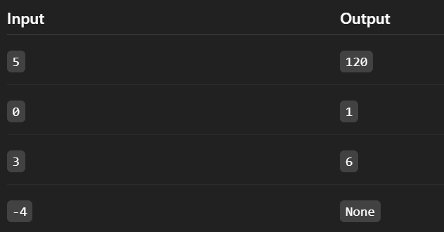
Comparison: Zero-Shot vs One-Shot
Aspect | Zero-Shot | One-Shot
Example Provided | ❌ No | ✅ Yes
Handling Negative Input | ❌ No | ✅ Yes
Clarity of Logic | Basic | Clear and safer
Correctness | Partial | More accurate
Edge-Case Awareness | Low | Improved

Explanation :
1.One-shot prompting improves clarity by providing an example, which helps the AI generate more accurate and complete logic.
- Compared to zero-shot prompting, the generated code handles edge cases (like negative input) better and is more reliable.

TASK 3: Few-Shot Prompting (Armstrong Number Check).
PROMPT: Write a Python function to check whether a given number is an Armstrong number.
Examples:
Input: 153 → Output: Armstrong Number
Input: 370 → Output: Armstrong Number
Input: 123 → Output: Not an Armstrong Number
CODE:
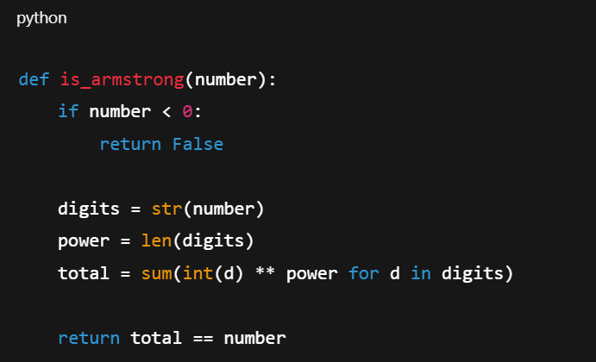
✅ Valid Inputs
Input | Output
153 | True
370 | True
123 | False
0 | True
1 | True

Boundary & Invalid Inputs
Input | Output | Observation
-153 | False | Negative numbers handled
10 | False | Correct non-Armstrong
"abc" | ❌ Error | No type validation
12.3 | ❌ Error | Float not handled
Explanation :
1.Providing multiple input–output examples helps the AI generate a more accurate and well-structured Armstrong number logic.
- Few-shot prompting improves correctness for known cases and boundary values, though input validation for invalid data is still required.

TASK 4: Context-Managed Prompting (Optimized Number
Classification)
PROMPT: “You are a backend Python developer.
Write an optimized Python function to classify a given input as Prime, Composite, or Neither.
Constraints:
• Validate input (only integers allowed).
• Handle edge cases such as 0, 1, and negative numbers.
• Optimize prime checking for efficiency (do not check all numbers up to n).
• Return clear string outputs without printing.”
CODE :
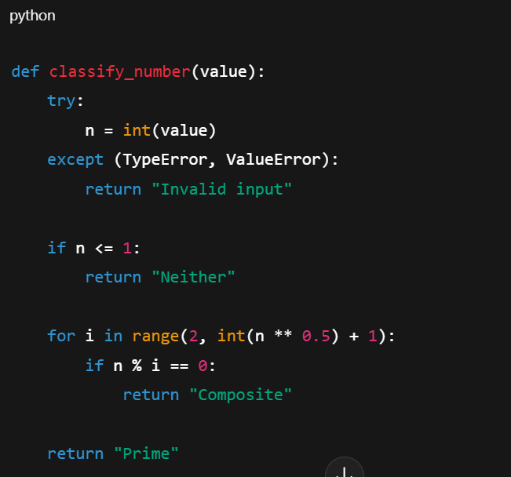
Input | Output
2 | Prime
7 | Prime
9 | Composite
15 | Composite
1 | Neither
0 | Neither
-5 | Neither

Aspect | Zero-Shot | Few-Shot | Context-Managed
Instructions | Minimal | Example-based | Detailed + constrained
Input Validation | ❌ Weak | ⚠️ Partial | ✅ Strong
Efficiency | ❌ Basic | ⚠️ Improved | ✅ Optimized (√n check)
Edge-Case Handling | ❌ Missing | ⚠️ Partial | ✅ Complete
Code Quality | Basic | Better | Professional / Backend-ready

Explanation (2 Points):
- Context-managed prompting gives the AI clear instructions and constraints, resulting in optimized, efficient, and professional code.
- Compared to zero-shot and few-shot prompts, it ensures input validation, handles edge cases, and improves overall correctness and reliability.

TASK 5: Zero-Shot Prompting (Perfect Number Check)
PROMPT: “Write a Python function that checks whether a given number is a perfect number and return false
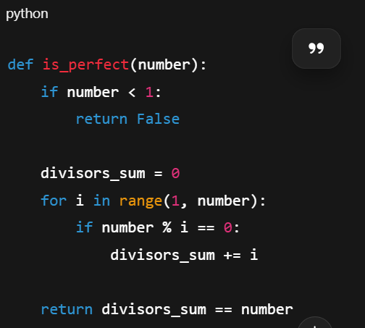
Testing the Code
Input | Output | Observation
6 | True | Correct (6 = 1 + 2 + 3)
28 | True | Correct (28 = 1 + 2 + 4 + 7 + 14)
12 | False | Correct non-perfect number
1 | False | Correct (1 has no proper divisors)
0 | False | Correct
-6 | False | Correct handling of negative numbers

EXPLANATION: Zero-shot prompting produces correct logic for basic perfect numbers, but the code is inefficient and lacks robust input validation.

TASK 6: Few-Shot Prompt Design (Even/Odd Classification with Validation
PROMPT: You are a Python programmer. Write a Python program that checks if a given number is even or odd. The program should also validate the input: if the input is not an integer, it should print "Invalid input
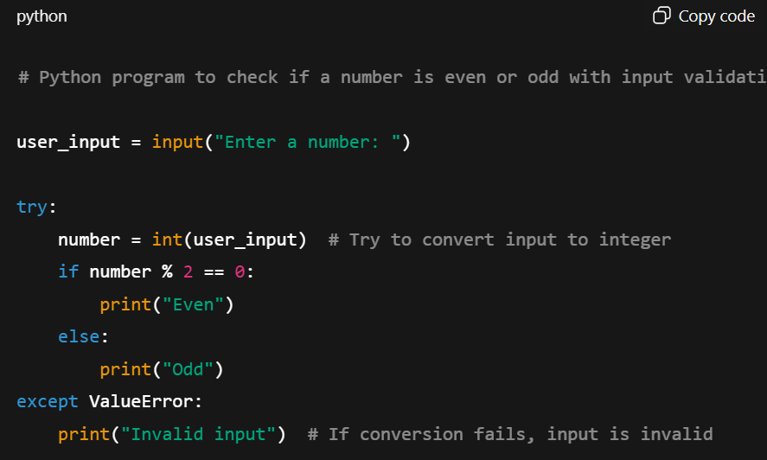
CODE:

Input | Expected Output | Notes
8 | Even | Positive even
15 | Odd | Positive odd
0 | Even | Edge case zero
-3 | Odd | Negative number
-12 | Even | Negative even
"hello" | Invalid input | Non-integer input
3.14 | Invalid input | Float input should be rejected

